Date: 17/ March / 2023

**Subject: Project completion Certificate**

**TO WHOMSOEVER IT MAY CONCERN**

This is to certify that **MS Meenakshi A (REG NO: 2101222078012)** Student of **M.SC (Computer Science)** of **Sri Sankara arts and science college** has completed her project work from **02 December 2022 to 09 March 2023.**

**Domain:** Python

**Title:** **Improving Performance of Product Recommendations using Users Review**

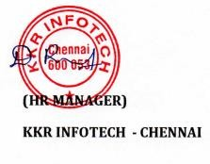Thank you for Engaging KKR INFOTECHs